**Dilyniannau**

CBAC Haf 2008 Mathemateg Ychwanegol Papur 1

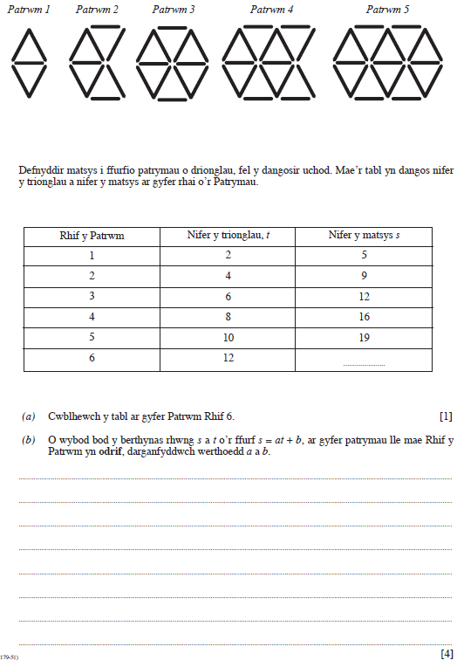

CBAC Haf 2010 Mathemateg Ychwanegol Papur 1

